SCUBA-2 Block Specification
cc_reset

Created on: 3 October 2005
Last saved on: 03 October 2005
Table of Contents

1. Block Description 3
1.1 Block Hierarchy 3
1.2 Block Overview and Features 3
1.3 Detailed Description 3
2. Interface Description 4
2.1 Signals Description 4
2.2 Protocol / Interface Timing 4
3. Dataflow Description 5
4. Source Files 6

Block Description

Block Hierarchy
This block resides on the clock card FPGA. It interfaces with the clock card HOTLink fibre optic receiver, and is used to generate a clock card firmware reset. It is instantiated by the top level clock card entity (clk_card.vhd).

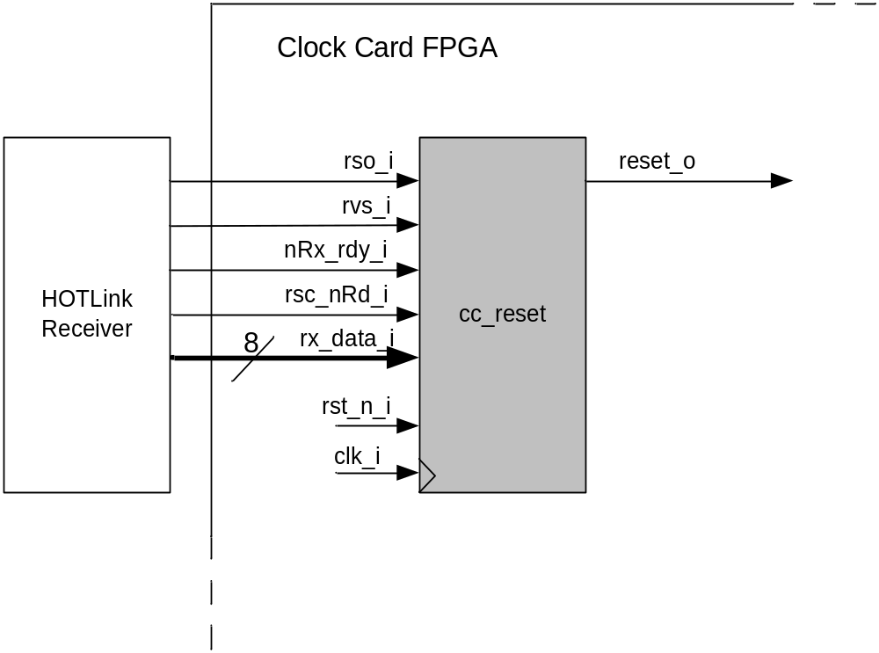

Block Overview and Features
This block generates a clock card firmware reset on receipt of a discrete fibre “special character”.

Detailed Description
The linux PC can issue a RESET MCE command, which forces the PCI card to send the “special character” 0x0B down the fibre (note that the HOTLink special character bit is set when this byte is sent). This block’s function is to detect this special character and on its receipt issue a clock card firmware reset.

Interface Description

Signals Description
 | Description | Direction
Global Signals
Clk_i | Global Clock (50Mhz) | In
rst_n_i | Global Reset | Out
Inputs from HOTLINK fibre receiver
nRx_rdy_i | HOTLink receiver data ready (active low) | In
rsc_nRd_i | HOTLink receiver special character/(not) Data | In
rso_i | HOTLink receiver status | In
rvs_i | HOTLink receiver violation symbol detected | In
rx_data_i | HOTLink receiver data byte | In
Outputs from Block
Reset_o | Global clock card firmware reset | Out

Protocol / Interface Timing

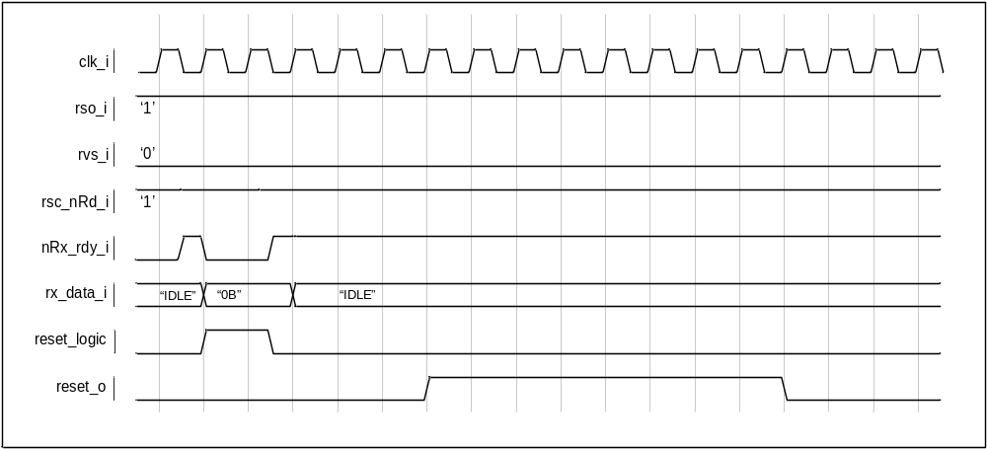

Dataflow Description

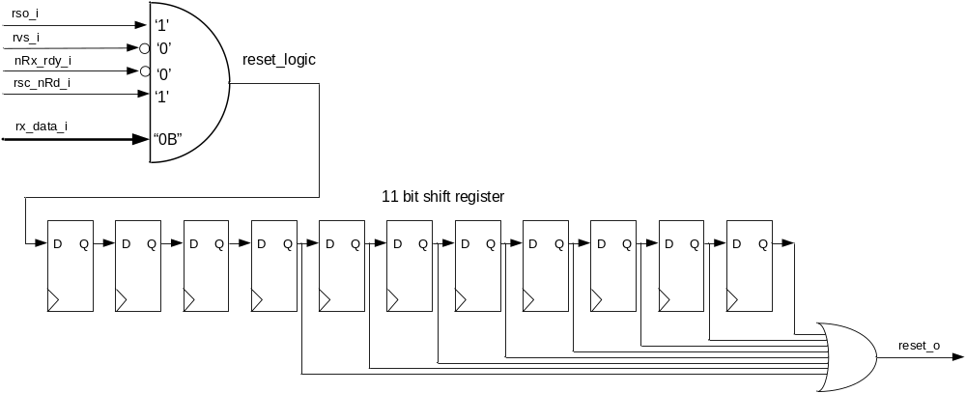

The shift register implementation provides protection against metastability.

Source Files

cc_reset.vhd
cc_reset_pack.vhd

